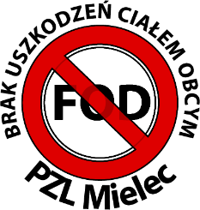

**Confirmation for contractors of familiarity with FOD requirements**

On behalf of the company   
I confirm receipt of training materials regarding the Foreign Object Damage (FOD) Prevention Program and commit to ensuring that all employees of the aforementioned company performing work at PZL Mielec acquaint themselves with the training materials (at least once a year) and adhere to the FOD Program guidelines.

………….……………….… …………..………………… ………………………

Town and date First name and surname Signature

I confirm that the employees of the company ……………………… are familliar with the training materials and have been briefed on adhering to FOD guidelines at PZL Mielec.

|  |  |  |  |
| --- | --- | --- | --- |
| L.p. | First name and surname | Date | Signature |
|  |  |  |  |
|  |  |  |  |
|  |  |  |  |
|  |  |  |  |
|  |  |  |  |
|  |  |  |  |
|  |  |  |  |
|  |  |  |  |
|  |  |  |  |
|  |  |  |  |
|  |  |  |  |
|  |  |  |  |
|  |  |  |  |
|  |  |  |  |
|  |  |  |  |
|  |  |  |  |
|  |  |  |  |
|  |  |  |  |
|  |  |  |  |
|  |  |  |  |
|  |  |  |  |
|  |  |  |  |

Information about the protection of personal data available at <https://pzlmielec.pl/en/privacy-policy>